UCS761 Deep Learning Project Report
Deep Learning-Based Pneumonia Detection from Chest X-Ray Images using MobileNetV4

Submitted by:
Pulkit Goyal (102303800)
Nitin Malhotra (102303918)
Prigya Goyal (102313061)
Erthanshu Singh (102303940)

B.E Third Year Batch – 3C64
Submitted to:
Dr. Stuti Chug

Ms. Diksha Arora

Computer Science and Engineering Department Thapar Institute of Engineering & Technology, Patiala
Table of Contents
- Introduction
- Literature Review
- Methodology
3.1 Overview of Approach
3.2 Dataset and Data Split
3.3 Data Preprocessing
3.4 Data Augmentation
3.5 Handling Class Imbalance
3.6 Model Architecture
3.7 Transfer Learning
3.8 Training Configuration
3.9 Training Process
3.10 Evaluation Metrics
3.11 Workflow Summary
- Results and Analysis
4.1 MobileNetV4 Results
4.2 CNN Baseline Results
4.3 Comparative Analysis
4.4 Confusion Matrix Analysis
4.5 Loss Curve Analysis
4.6 Grad Cam Analysis
- Conclusion
- References

1. Introduction
Pneumonia is a serious lung infection that affects millions of people worldwide and can become life-threatening if not diagnosed early. Chest X-ray imaging is one of the most widely used diagnostic tools for detecting pneumonia. However, manual interpretation of X-rays requires experienced radiologists and can be time-consuming, especially in hospitals with a high patient load.
With the advancement of artificial intelligence, deep learning has emerged as a powerful technique for medical image analysis. Convolutional Neural Networks (CNNs) are capable of automatically learning patterns from images, enabling faster and more consistent diagnosis.
In this project, a deep learning-based system is developed to classify chest X-ray images into two categories: Normal and Pneumonia. The primary model used is MobileNetV4, which is designed to be both efficient and accurate.
Additionally, a baseline CNN model is implemented to compare performance and demonstrate the effectiveness of the proposed approach. The goal is to develop a system that is not only accurate but also practical for real-world medical use.

2. Literature Review
Deep learning has significantly improved medical image analysis, particularly for detecting diseases from chest X-ray images. Various architectures have been developed to enhance classification accuracy, computational efficiency, and generalization.
K. He et al. [1] introduced Residual Networks (ResNet), which use skip connections to enable the training of very deep neural networks. This helps overcome the vanishing gradient problem and improves feature learning. However, ResNet models are computationally expensive, making them less suitable for real-time medical applications.
G. Huang et al. [2] proposed DenseNet, where each layer is connected to every other layer. This improves feature reuse and gradient flow, which is beneficial for detecting subtle patterns in medical images. However, DenseNet increases memory usage due to dense connections.
Rajpurkar et al. [3] developed CheXNet, a DenseNet-based model that achieved performance comparable to radiologists in pneumonia detection. This demonstrated the potential of deep learning in healthcare, but the model is computationally heavy and less efficient for deployment.
Howard et al. [4] introduced MobileNet, a lightweight convolutional neural network using depthwise separable convolutions. This significantly reduces computational cost while maintaining accuracy. Later versions such as MobileNetV3 [5] further improved efficiency using advanced architectural techniques.
Tan and Le [6] proposed EfficientNet, which scales network dimensions in a balanced way to achieve high accuracy. However, it requires more computational resources compared to lightweight models.
Dosovitskiy et al. [7] introduced Vision Transformers (ViT), which use attention mechanisms instead of convolution operations. While effective, these models require large datasets and high computational power.
MobileNetV4 [8], introduced in 2024, improves both accuracy and efficiency through optimized architecture design, making it suitable for real-world deployment in healthcare systems.
Research Gap
From the literature, the following gaps are identified:
- High-performing models require high computational resources
- Lightweight models may compromise on accuracy
- Limited focus on balancing accuracy, efficiency, and deployability
Proposed Approach
To address these challenges, this project:
- Uses MobileNetV4, a modern and efficient model
- Implements a baseline CNN model for comparison
- Applies data augmentation and class imbalance handling to improve performance
This approach ensures both high accuracy and practical usability in real-world medical applications.

3. Methodology
3.1 Overview of Approach
This project follows a deep learning-based approach to classify chest X-ray images into two categories: Normal and Pneumonia. The workflow includes data preprocessing, augmentation, model training, validation, and evaluation.
Two models are implemented:
- Baseline Model: Simple Convolutional Neural Network (CNN)
- Proposed Model: MobileNetV4
The baseline CNN provides a reference for comparison, while MobileNetV4 demonstrates improved performance using advanced architecture and transfer learning.
3.2 Dataset and Data Split
The dataset used consists of chest X-ray images categorized into two classes: Normal and Pneumonia.
The dataset contains a total of 6,480 images, divided as follows:
Dataset Split | Number of Images
Training + Validation | 5,856
Test | 624
The training data is further split using an 85:15 stratified split:
Split | Number of Images
Training | ~4,977
Validation | ~879
Reason for stratified split:
Maintains equal class distribution across training and validation sets, ensuring unbiased learning.
3.3 Data Preprocessing
Before training, the following preprocessing steps are applied:
- Resizing: All images are resized to 224 × 224 pixels
- Color Conversion: Grayscale images are converted to RGB format
- Normalization: Pixel values are normalized using standard mean and standard deviation
Why these steps are required:
- Deep learning models require fixed input size
- Pretrained models expect RGB input
- Normalization improves training stability and convergence
3.4 Data Augmentation
To improve model generalization and handle limited data, the following augmentation techniques are used:
- Horizontal flipping
- Random brightness and contrast adjustment
- Rotation and scaling
- CLAHE (contrast enhancement)
Reason:
- Increases dataset diversity
- Prevents overfitting
- Helps model perform well on real-world variations
3.5 Handling Class Imbalance
The dataset contains more pneumonia images than normal images. To address this imbalance:
- Class weights are applied in the loss function
- WeightedRandomSampler is used during training
Why:
- Prevents bias toward the majority class
- Ensures balanced learning for both classes
3.6 Model Architecture
(A) Baseline CNN
The baseline CNN consists of:
- Three convolutional layers
- ReLU activation functions
- Max pooling layers
- Fully connected layers
Limitation:
- Limited depth results in weaker feature extraction
- No pretrained knowledge

(B) Proposed Model: MobileNetV4
MobileNetV4 is a pretrained deep learning model designed for efficient image classification.
Key features:
- Depthwise separable convolutions
- Lightweight architecture
- Pretrained on large datasets
Why chosen:
- Better feature extraction
- Faster inference
- Suitable for real-world deployment
3.7 Transfer Learning
The MobileNetV4 model is initialized with pretrained weights and modified for binary classification.
Why transfer learning is used:
- Medical datasets are relatively small
- Pretrained models already capture general image features
- Improves accuracy and reduces training time

3.8 Training Configuration
The models are trained using the following parameters:
Parameter | Value
Loss Function | CrossEntropyLoss (with class weights)
Optimizer | AdamW
Learning Rate | 0.0001
Scheduler | CosineAnnealingLR
Epochs | 8
Batch Size | 32
Justification:
- CrossEntropyLoss is suitable for classification tasks
- AdamW improves generalization
- CosineAnnealing ensures smooth convergence
3.9 Training Process
The training process includes:
- Input images are passed through the model
- Predictions are generated
- Loss is calculated
- Backpropagation updates model weights
- Learning rate is adjusted using scheduler
Validation is performed after each epoch to monitor performance.
Why validation is important:
- Helps detect overfitting
- Ensures model generalization
3.10 Evaluation Metrics
The model is evaluated using:
- Accuracy
- Precision
- Recall
- F1-score
- Confusion Matrix
Reason:
- Accuracy gives overall performance
- Precision and recall provide class-wise insight
- F1-score balances both
3.11 Workflow Summary
The complete workflow is:
Data Collection → Preprocessing → Augmentation → Training → Validation → Testing → Evaluation
This structured approach ensures reliable and reproducible results.

4. Results and Analysis
4.1 Proposed Model (MobileNetV4) Results
The proposed MobileNetV4 model achieved the following results:
Class | Precision | Recall | F1-Score
NORMAL | 0.98 | 0.70 | 0.81
PNEUMONIA | 0.84 | 0.99 | 0.91
- Accuracy: 88%
- Weighted F1-score: 0.87
Interpretation
- The model achieves very high recall (0.99) for pneumonia
- This means almost all pneumonia cases are correctly detected
- Slightly lower recall for normal class indicates some false positives
In medical applications, this behavior is acceptable because:
- Missing a disease is more dangerous than false detection
4.2 CNN Baseline Results
The baseline CNN model achieved the following performance:
Class | Precision | Recall | F1-Score
NORMAL | 0.94 | 0.43 | 0.59
PNEUMONIA | 0.74 | 0.98 | 0.85
- Accuracy: 78%
Interpretation
- CNN performs well in detecting pneumonia
- However, it performs poorly on normal cases
- This indicates limited feature extraction capability
4.3 Comparative Analysis
Metric | CNN (Baseline) | MobileNetV4
Accuracy | 78% | 88%
F1-score (Normal) | 0.59 | 0.81
F1-score (Pneumonia) | 0.85 | 0.91
MobileNetV4 significantly outperforms CNN
Improvement is due to:
  - Transfer learning
  - Better architecture
  - More effective feature extraction
Conclusion:
The proposed model provides both higher accuracy and better balance between classes.

4.4 Confusion Matrix Analysis
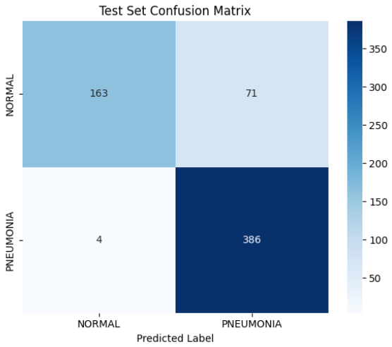
The confusion matrix shows that most pneumonia cases are correctly classified, with very few false negatives.
Key Observations
- High number of correctly classified pneumonia cases
- Some normal images misclassified as pneumonia
- Very few pneumonia cases are missed
Interpretation:
- Model prioritizes detecting disease
- This is desirable in healthcare applications

4.5 Loss Curve Analysis
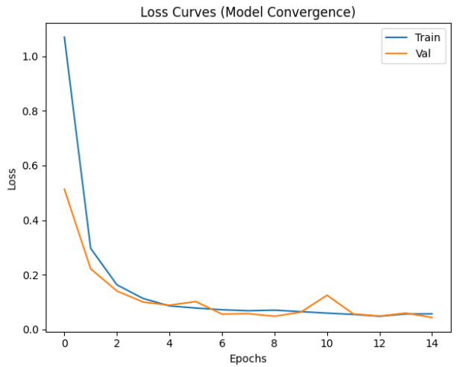
The loss curves show a steady decrease in training loss and stable validation loss, indicating good learning and minimal overfitting.
Purpose
- To monitor learning behavior
- To detect overfitting or underfitting
Observations
- Training loss decreases steadily
- Validation loss stabilizes after initial epochs
Conclusion:
The model is well-trained and shows good generalization without significant overfitting.

4.6 Grad-CAM Analysis (Model Interpretability)
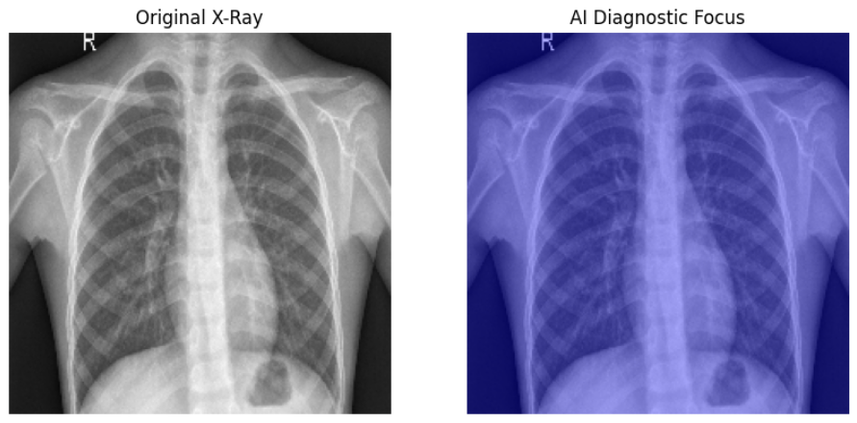
Purpose
- To understand model decision-making
- To improve trust in predictions
Observations
- The model focuses on lung regions
- Highlights infected areas in pneumonia cases
- Shows minimal activation in normal regions
Conclusion:
The model is learning meaningful medical features rather than random patterns.
4.8 Overall Findings
- MobileNetV4 achieves higher accuracy and better performance than CNN
- The model is highly effective in detecting pneumonia cases
- Visualization techniques confirm correct learning behavior
5. Conclusion
This project successfully demonstrates the application of deep learning techniques for detecting pneumonia from chest X-ray images. Two models were implemented: a baseline Convolutional Neural Network (CNN) and an advanced MobileNetV4 model.
The experimental results show that MobileNetV4 significantly outperforms the baseline CNN. The proposed model achieved an accuracy of 88%, compared to 78% for the CNN. Additionally, it achieved a high recall of 0.99 for pneumonia detection, which is particularly important in medical applications where missing a disease can have serious consequences.
The improvement in performance can be attributed to the use of transfer learning, better feature extraction, and an efficient architecture. The use of data augmentation and class imbalance handling further enhanced model robustness and generalization.
The baseline CNN model, while simpler, showed limitations in correctly identifying normal cases, highlighting the importance of using advanced architectures for medical image analysis.
Overall, the proposed system is efficient, reliable, and suitable for real-world healthcare applications. It has the potential to assist medical professionals by providing faster and more accurate diagnosis.

6. References
[1] K. He, X. Zhang, S. Ren, and J. Sun, “Deep Residual Learning for Image Recognition,” Proceedings of the IEEE Conference on Computer Vision and Pattern Recognition (CVPR), pp. 770–778, 2016.
[2] G. Huang, Z. Liu, L. Van Der Maaten, and K. Q. Weinberger, “Densely Connected Convolutional Networks,” Proceedings of the IEEE Conference on Computer Vision and Pattern Recognition (CVPR), pp. 4700–4708, 2017.
[3] P. Rajpurkar, J. Irvin, K. Zhu, et al., “CheXNet: Radiologist-Level Pneumonia Detection on Chest X-Rays with Deep Learning,” arXiv preprint arXiv:1711.05225, 2017.
[4] A. G. Howard et al., “MobileNets: Efficient Convolutional Neural Networks for Mobile Vision Applications,” arXiv preprint arXiv:1704.04861, 2017.
[5] A. Howard et al., “Searching for MobileNetV3,” Proceedings of the IEEE International Conference on Computer Vision (ICCV), pp. 314–1324, 2019.
[6] M. Tan and Q. Le, “EfficientNet: Rethinking Model Scaling for Convolutional Neural Networks,” Proceedings of the International Conference on Machine Learning (ICML), pp. 6105–6114, 2019.
[7] A. Dosovitskiy et al., “An Image is Worth 16×16 Words: Transformers for Image Recognition at Scale,” International Conference on Learning Representations (ICLR), 2021.
[8] Google Research, “MobileNetV4: Universal Models for Efficient Inference,” 2024. (Technical report / official release)

